Inter widget communication with passing object and integrate two widget with Rest Service :

**Reference:**

<https://community.backbase.com/documentation/Retail-Banking/latest/how-to-communicate-between-widgets>

https://community.[backbase](https://community.backbase.com/documentation/Wealth-Management/latest/work_with_rest_data_services).com/documentation/Wealth-Management/latest/work_with_rest_data_services

**Steps**:

1. Pass object from one widget to another widget via Activated Route:-

**account-selector-widget.component.ts** :-

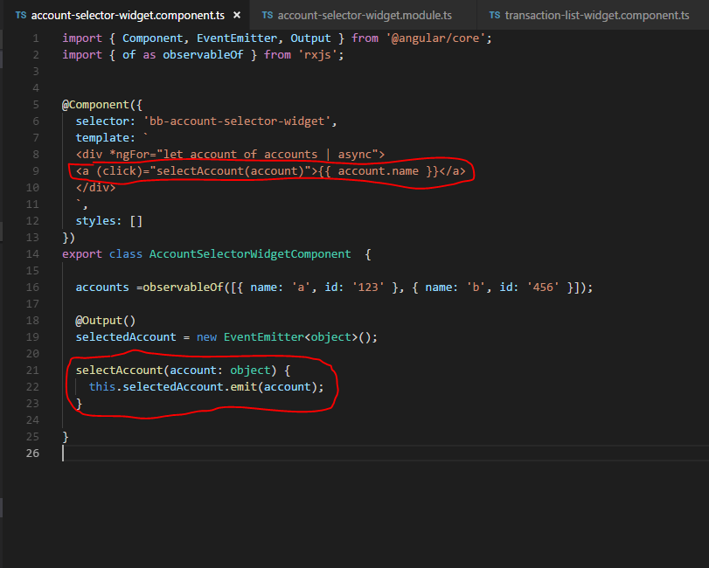

1. **transaction-list-widget.ts file**

s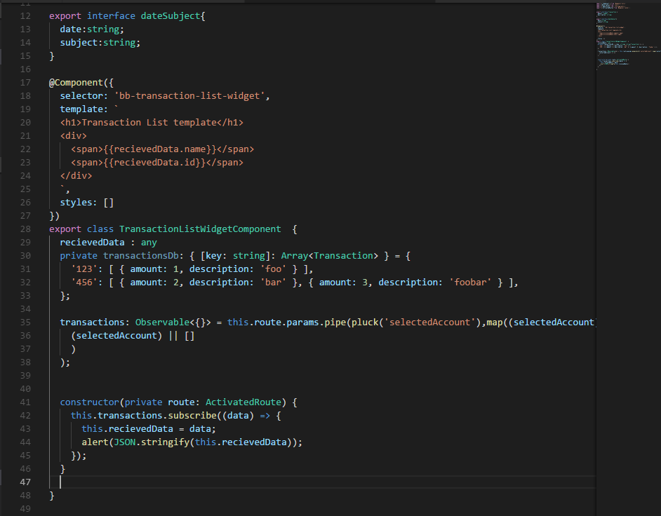

During first page load, object data are available in transaction-list-widget. But after clicking on selected account on **account-selector-widget** , account object are not passed to transaction-list-widget.

**Issues integrating inter-widget communication with Rest service**

1. Created two widgets with two data modules   
   - list-widget  
    - list-data  
   - todo-widget  
    - todo-data  
     
   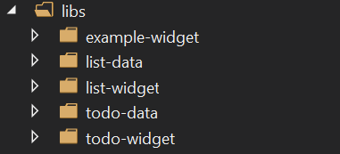
2. Update dev-mock.js accordingly   
   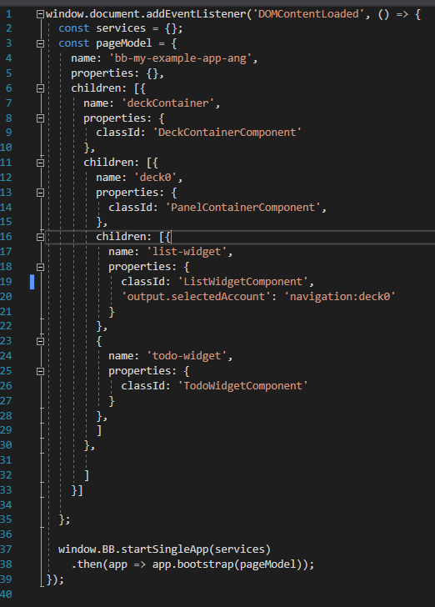
3. Emit Selected Account id from list –widget component.
4. 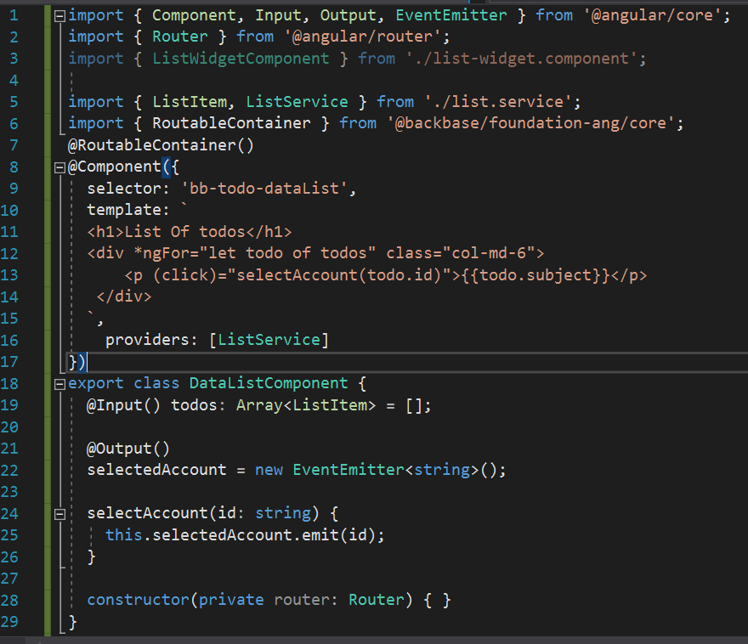
5. List-widget structure

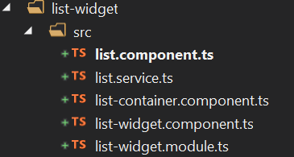  
  
  
list-data is integrated with list-widget and the rest service is working fine   
output in browser -   
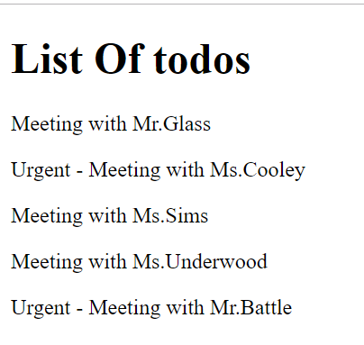

1. Next data module is integrated with todo-widget , and we are trying to communicate between list-widget to todo-widget with id , but certainly the routing is not working .  
     
   When we try to click on the any list of todo it is not showing any data as-well the browser URL also not updated with params